Chapter 5, Problem 26

Using Fig. 5.64, design a problem to help other students better understand noninverting op amps.
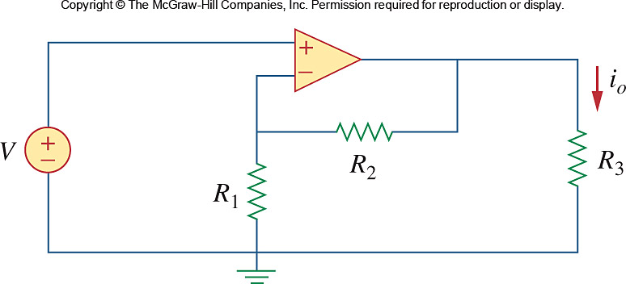

Figure 5.64
For Prob. 5.26.

